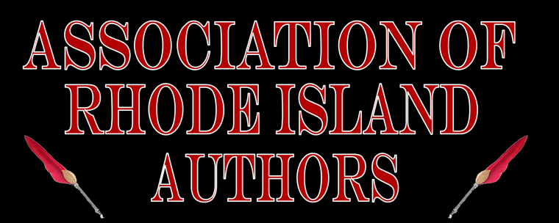
1st ANNUAL RHODE ISLAND AUTHORS EXPO
BOOSTER
Only $50.00
Support the 1st Annual Rhode Island Author's Expo and be recognized!
NAME________________________________________________________________________________
LISTING NAME_______________________________________________________________________
MAILING ADDRESS______________________________________________________________________
_____________________________________________________________________________________
PHONE__________________________EMAIL________________________________________________
ENCLOSED: $50.00 (Booster)
$_______ (Additional Donation)
- Location: Courthouse Center for the Arts, 3481 Kingstown Road, Kingston, RI 02892
- Show Hours: Saturday, November 16, 2013, 10 a.m. to 3 p.m.
- Recognition: Boosters will be recognized on ARIA's website, via social media, in the official program, and on signage on the day of the show.

Please enclose a check to The Association of Rhode Island Authors and mail it to: The Association of Rhode Island Authors, c/o Steven R. Porter, 63 Sawmill Road, Chepachet, RI 02814. For more information, email Authors@RIAuthors.org or call Steve at (401) 309-7494.

